Database


Quiz #01
Section BSCS (5A)

Submitted By
QASIM ALI (20P-0070)
Submitted to :
(INSTRUCTOR CS)

DEPARTMENT OF COMPUTER SCIENCE

FAST NATIONAL UNIVERSITY OF COMPUTER AND EMERGING SCIENCES, PESHAWAR

Session 2020-2024
1. Database and Table Creation
Create a database named &quot;University&quot; with the following tables:

Ans:
CREATE DATABASE University;

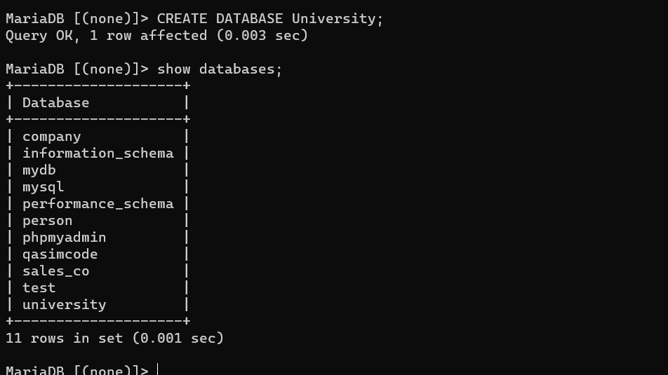

a: Students table:
StudentID (Primary Key)
FirstName
LastName
Age
Major

Ans:
Create table Students( StudentsID int Primary Key, firstName varchar(50) not null , lastName varchar(50), age int not null,Major varchar(50) not null );

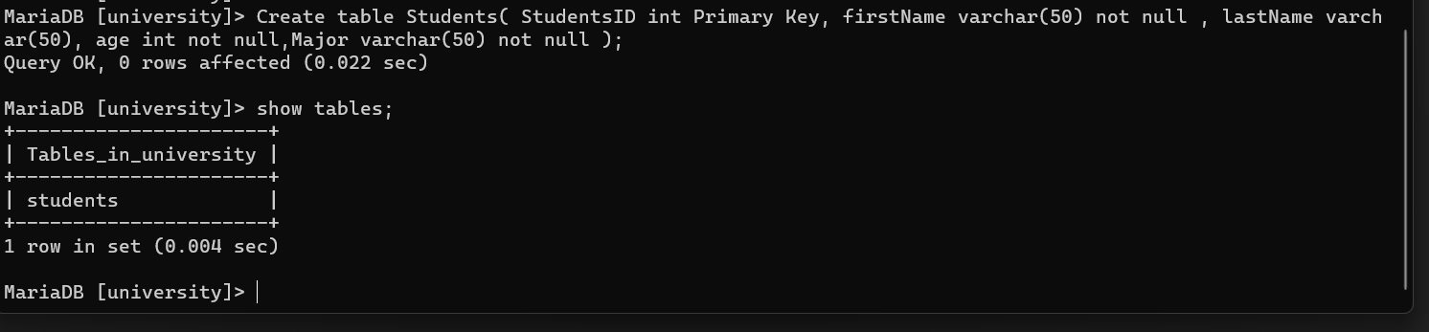

b. Courses table:
CourseID (Primary Key)
CourseName
Instructor

Ans:
Create table Courses (CourseID int Primary Key, CourseName varchar(50) not null , Instructor varchar(50) not null );

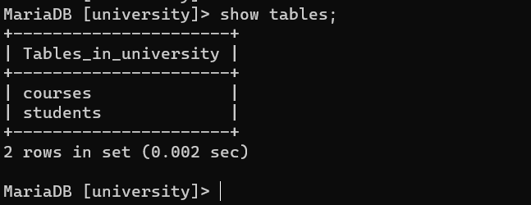
2: Insert Data
Insert at least 5 records into the Students table and 3 records into the Courses table.

Ans: insert Students values:
insert into Students (StudentsID, firstName, lastName, age, major) values ('1','Qasim', 'ali', 20, 'Computer Science');

insert into Students (StudentsID, firstName, lastName, age, major) values ('2','Muhmmad', 'Rafay', 21, 'Computer Science');

insert into Students (StudentsID, firstName, lastName, age, major) values ('3','Ahmad', 'ali', 19, 'Computer Science');

insert into Students (StudentsID, firstName, lastName, age, major) values ('4','jawad', 'ahmad', 18, 'Computer Science');

insert into Students (StudentsID, firstName, lastName, age, major) values ('5','mani', 'khan', 22, 'Computer Science');

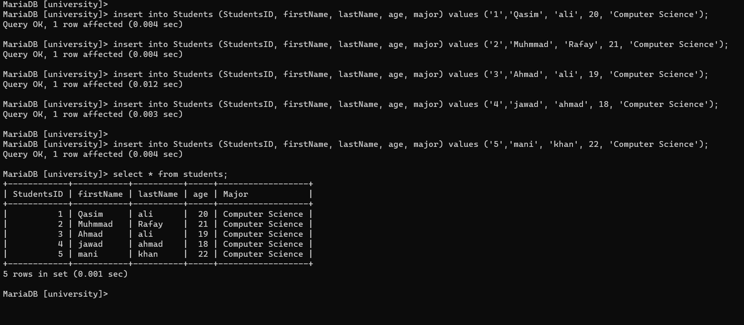

insert Courses values:

insert into Courses (CourseID , CourseName ,Instructor) values ('1','Calculus', 'Dr.askar');

insert into Courses (CourseID , CourseName ,Instructor) values('2','Python Programming', 'waqas ahmad');

insert into Courses (CourseID , CourseName ,Instructor) values('3','Data Structures', 'Fazal basti');

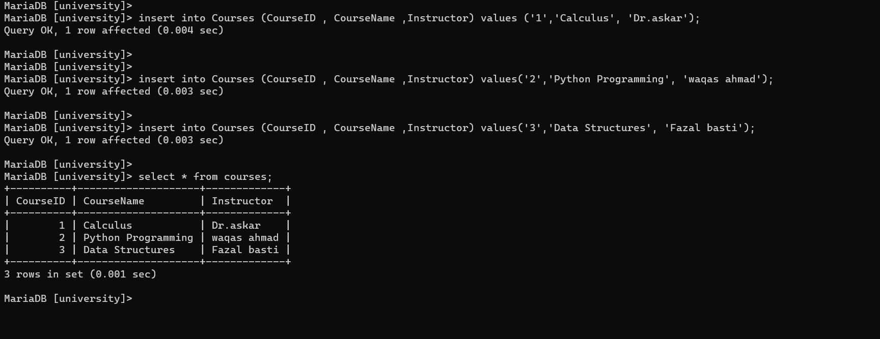

3. SQL Queries

SELECT firstName, lastName, major FROM Students;

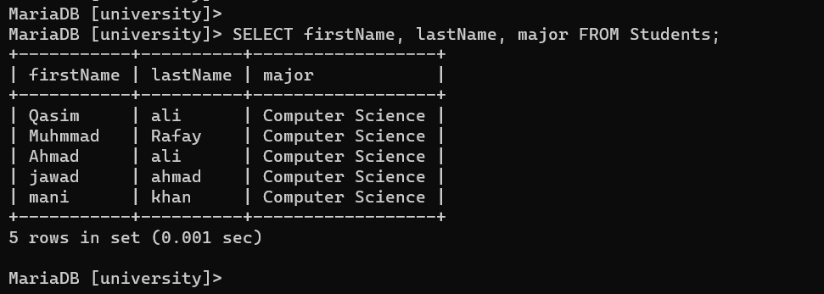

SELECT CourseName, Instructor FROM Courses WHERE Instructor = 'Dr.askar';
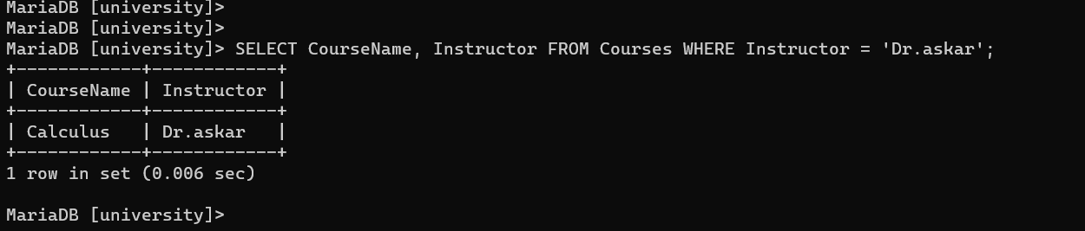

SELECT major, COUNT(*) AS StudentCount FROM Students GROUP BY major;
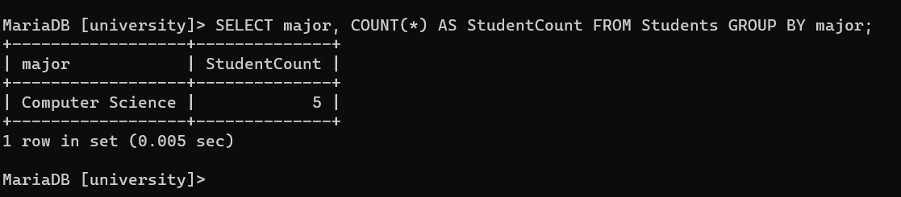

4: Update Operations
Update the age of a specific student in the Students table.

UPDATE Students
SET Age = 24
WHERE StudentsID = 1;

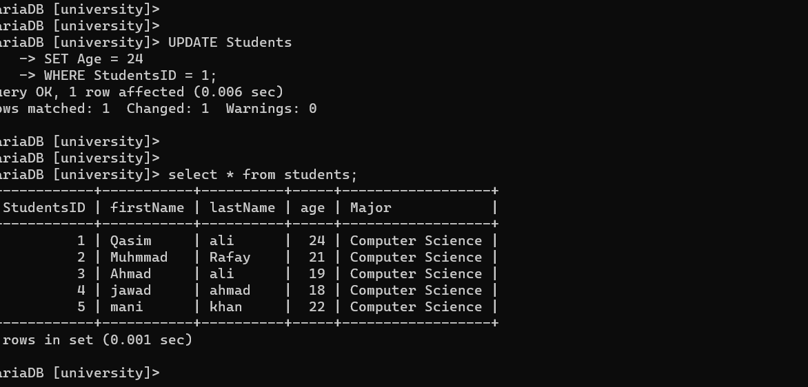

5 Delete Operation

Delete a course from the Courses table.

DELETE FROM Courses
WHERE CourseID = 1;

